*Florida International University*

*School of Computing and Information Sciences*

Software Engineering Focus

Feature Document

User Story ID #673 Module collision detection

**Name: Daniel Rivero**

**Team Member(s):** Pachev Joseph, Hamilton Chevez, Bernardo Pla, Daniel Khawand

**Project: WebVR 1.0**

**Product Owner(s)**:

**Mentor(s)**: Francisco Ortega

**Instructor**: Masoud Sadjadi

**User Story Name: Module collision detection**

* Description: As a user who plays this game, I want the robot to be able to detect modules that are placed on its programming board so that I can give commands to the robot.

Acceptance Criteria

* Functionality of the board should be animated
* The board should only detect collisions with objects that are tagged ‘Module’

**Use Case**

* Name: Using a module
* Actor: User, Module, Robot
* Preconditions: The Player has a module in their inventory
* Description :
* User walks to robot
* User takes out module from inventory
* User presses the button on the robot to open the programming table
* User places module onto of the programming table
* User presses run
* Robot melts modules on the table
* Robot closes programming table
* Robot executes the command provided by the module

**Use Case Diagram**

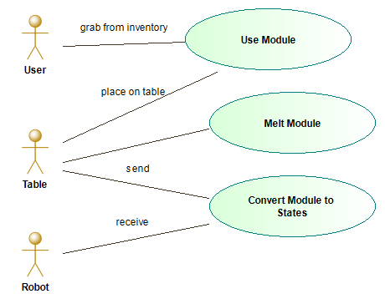

**Sequence Diagram**

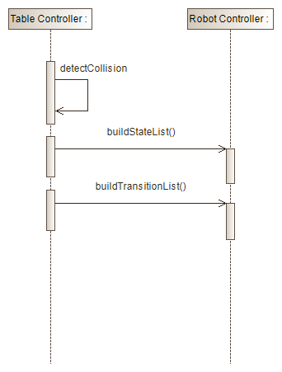

**Class Diagram**

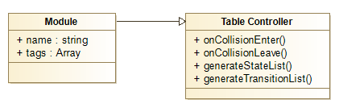

**Unit Test**

* Test case ID:
* Description/Summary of Test:
* Pre-condition:
* Expected Results:
* Actual Result:
* Status (Fail/Pass):

**Integration Test**

**Visual User Guide** <like one or two screenshots of the feature. For the hardware project, a photo of device is required>

Florida International University  
School of Computing and Information Sciences  
  
   
Software Engineering Focus  
  
  
  
  
Feature Document  
  
  
  
  
User Story ID <ID in the Mingle>  
  
  
  
  
  
  
  
  
  
  
Name:  
  
Team Member(s):  
  
Project:  
   
Product Owner(s):   
   
Mentor(s):   
   
Instructor: Masoud Sadjadi  
  
  
  
User Story Name:  
  
Description: As a User I would like to ….. so that I …..  
  
Acceptance Criteria  
  
  
  
  
  
  
  
Use Case  
Name:  
Actor:  
Preconditions:  
Description <Flow of events>:  
  
  
  
Use Case Diagram <you can use draw.io>  
  
  
  
  
Sequence Diagram  
  
  
  
  
Class Diagram  
  
  
  
  
Unit Test  
Test case ID:   
Description/Summary of Test:   
Pre-condition:   
Expected Results:   
Actual Result:   
Status (Fail/Pass):  
  
  
Integration Test  
  
  
  
  
Visual User Guide <like one or two screenshots of the feature. For the hardware project, a photo of device is required>